Supplement
Work Measurement

Discussion Questions
1. Labor standards are set in four ways: historical experience, time studies, predetermined time standards, and work sampling.
2. Normal time adjusts the observed time to what a normal worker could be expected to accomplish by multiplying the average observed cycle time by a performance rating factor.
3. Labor standards are used to:
1. Determine labor content of items produced
2. Determine staffing needs of organizations
3. Determine cost and time estimates prior to production
4. Determine crew size and work balance
5. Determine production expected
6. Determine the basis of wage-incentive plans
7. Determine efficiency of employees and supervision
4. The observations should be handled as follows:
(a) An extra long look: judgment as to quality: include in the standard
(b) Imperfection causing difficulty in fitting the piece into the jig: include in the standard
(c) Change tool: include in the standard
5. Standard time is normal time that has been adjusted for
appropriate allowances.
6. Not all employees respond the same way, but one would usually expect an employee to work somewhat slower than normal while being observed. The employee perceives that the faster he or she works during evaluation, the higher the normal rate will be set. Conversely, other employees take pride in superior performance and work faster than a normal pace.
7. Classify as follows:
a) The operator stops to talk to you: do not include (delay)
b) The operator lights up a cigarette: do not include (personal)
c) Operator opens lunch pail: do not include (personal)
8. Waiting time: waiting time is included in an allowance as delay.
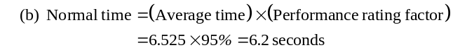 9. Material movement or replenishment: include in the standard unless a separate materials handling group exists.
10. Operator drops a part, you pick it up and hand it to him: do not include. Outside help or interference distorts the results of the study.
11. Gilbreth’s approach to setting work standards is to divide manual work into small basic elements that already have established time. Units of time are very small (0.0006 minutes) and are called Therbligs.
Active Model Exercise
Active Model S10.1: Work Sampling
1. Scroll over the graph to determine what the sample size should be if p = 30%.
933
2. Based on the graph, what value of p requires the largest sample size?
0.5
3. Use the scrollbar to determine what happens to the sample size as the number of standard deviations, z, increases?
The sample size increases.
4. Use the scrollbar to determine what happens to the sample size as the acceptable error, h, increases?
The sample size decreases.
End-of-Supplement Problems
S10.1 The next step should probably be to take another set of observations. The time of 56 seconds would appear to be an outlier and should be investigated further. It may represent the impact of a problem with the process, or with inferior raw materials, or an error in data collection.
S10.2 NT = Avg × PR = 8.5 × 1.10 = 9.35 seconds; worker is faster than normal
S10.3 NT = Avg × PR = 8.5 × 0.90 = 7.65 seconds; worker is slower than normal
S10.4 (a) 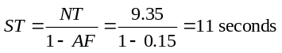
(b) 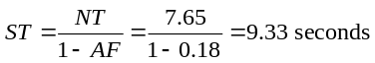
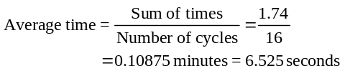S10.5 (a)
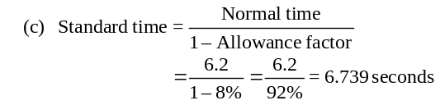
S10.6 NT = Cycle time × PR = (50) × (1.10) = 55 seconds
S10.7 (a) Normal time = 12 minutes × 1.05 = 12.6 minutes
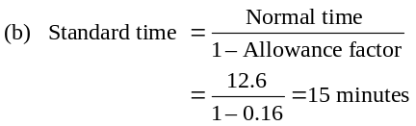
S10.8 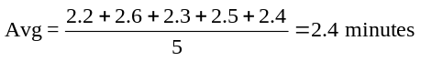
NT = 2.4 × 1.05 = 2.52
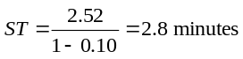
S10.9 (a) Normal time = 12 seconds × 1.00 = 12.0 seconds
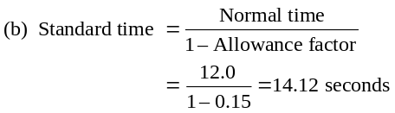
S10.10 Normal time = 5.3 minutes × 1.05 = 5.565 minutes
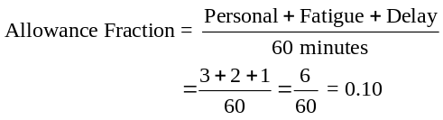
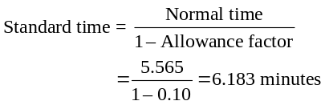
S10.11 Normal time = 25 minutes
Allowances = 5 + 10 + 2 = 17 min per hour
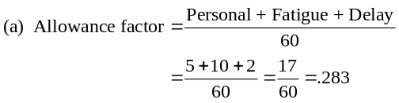
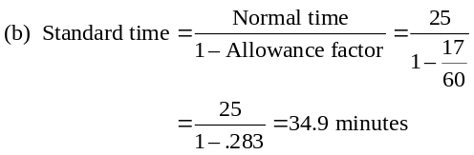
S10.12
 |  | Observation (minutes per cycle)
Element | Rating | 1 | 2 | 3 | 4 | 5 | Average Time | Normal Time
1 | 100% | 1.5 | 1.6 | 1.4 | 1.5 | 1.5 | 1.5 | 1.50
2 | 90% | 2.3 | 2.5 | 2.1 | 2.2 | 2.4 | 2.3 | 2.07
3 | 120% | 1.7 | 1.9 | 1.9 | 1.4 | 1.6 | 1.7 | 2.04
4 | 100% | 3.5 | 3.6 | 3.6 | 3.6 | 3.2 | 3.5 | 3.50
Normal time for lab test = 9.11
(a) As shown below, normal time = 3.24 minutes.
S10.13
 |  |  | Observation (minutes per cycle)
Element | Rating | 1 |  | 2 | 3 | 4 | 5 | Average |  | Normal
Check mini-bar | 100% | 1.5 |  | 1.6 | 1.4 | 1.5 | 1.5 | 1.5 |  | 1.50
Make one bed | 90% | 2.3 |  | 2.5 | 2.1 | 2.2 | 2.4 | 2.3 |  | 2.07
Vacuum | 120% | 1.7 |  | 1.9 | 1.9 | 1.4 | 1.6 | 1.7 |  | 2.04
Clean bath | 100% | 3.5 |  | 3.6 | 3.6 | 3.6 | 3.2 | 3.5 |  | 3.50
 |  |  |  |  |  |  |  |  |  |  | 9.11
Normal time for process = 9.11
S10.14
Job Element |  | Observed Time (minutes) |  |  |  |  | Perf. Rating
Typing letter | 2.5 | 3.5 | 2.8 | 2.1 | 2.6 | 3.3 | 85%
Typing envelope | 0.8 | 0.8 | 0.6 | 0.8 | 3.1a | 0.7 | 100%
Stuffing envelope | 0.4 | 0.5 | 1.9a | 0.3 | 0.6 | 0.5 | 95%
Sealing, sorting | 1.0 | 2.9b | 0.9 | 1.0 | 4.4b | 0.9 | 125%
a Disregard—secretary stopped to answer the phone.
b Disregard—interuption by supervisor.
Calculating average cycle time:
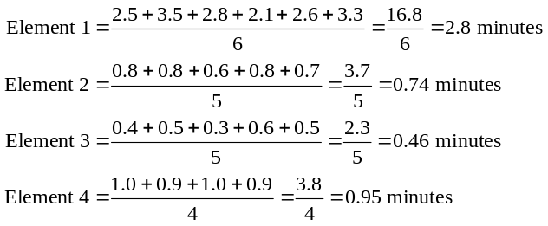

Standard time for process:
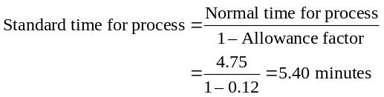
S10.15 Allowance = 23%
 |  |  | Observations (minutes)
Job  Element | Performance  Rating | 1 |  | 2 | 3 | 4 | 5
1 | 97% | 1.5 |  | 1.8 | 2.0 | 1.7 | 1.5
2 | 105% | 0.6 |  | 0.4 | 0.7 | 3.7 | 0.5
3 | 86% | 0.5 |  | 0.4 | 0.6 | 0.4 | 0.4
4 | 90% | 0.6 |  | 0.8 | 0.7 | 0.6 | 0.7
The first thing to notice is that observation 4 of job element
2 is personal time and should be ignored.

Calculating normal time for each task element:
Normal time = Observed cycle time × Peformance rating
Element 1 = 2.80 × 0.85 = 2.38 minutes
Element 2 = 0.74 × 1.00 = 0.74 minutes
Element 3 = 0.46 × 0.95 = 0.44 minutes
Element 4 = 0.95 × 1.25 = 1.19 minutes
Normal time for the process:
Normal time for process = Sum of normal times for elements
= 2.38 + 0.74 + 0.44 + 1.19
= 4.75 minutes

 |  |  | Observations
Job  Element | Performance  Rating | 1 |  | 2 | 3 | 4 | 5 |  | Average  Actual Time | Normal  Time
1 | 97% | 1.5 |  | 1.8 | 2.0 | 1.7 | 1.5 |  | 1.70 | 1.65
2 | 105% | 0.6 |  | 0.4 | 0.7 |  | 0.5 |  | 0.55 | 0.58
3 | 86% | 0.5 |  | 0.4 | 0.6 | 0.4 | 0.4 |  | 0.46 | 0.40
4 | 90% | 0.6 |  | 0.8 | 0.7 | 0.6 | 0.7 |  | 0.68 | 0.61
 |  |  |  |  |  |  |  |  |  |  | 3.24
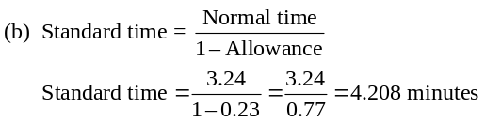
S10.16 (a,b)
 |  |  | Observations (minutes)  (actual time) |  |  |  |  |  |  | Solutions
Task  Element | Performance  Rating | 1 |  | 2 | 3 | 4 | 5 |  | Actual  Time Average |  | Normal  Time
1 | 110% | 0.5 |  | 0.4 | 0.6 | 0.4 | 0.4 |  | 0.46 |  | 0.506
2 | 95% | 0.6 |  | 0.8 | 0.7 | 0.6 | 0.7 |  | 0.68 |  | 0.646
3 | 90% | 0.6 |  | 0.4 | 0.7 | 0.5 | 0.5 |  | 0.54 |  | 0.486
4 | 85% | 1.5 |  | 1.8 | 2.0 | 1.7 | 1.5 |  | 1.70 |  | 1.445
 |  |  |  |  |  |  |  |  | Total |  |  | 3.083
(a) Normal time = 3.083 minutes
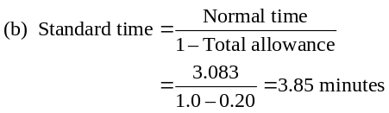
S10.17 Initial sample: 3.5, 3.2, 4.1, 3.6, 3.9
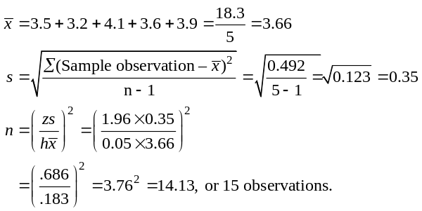
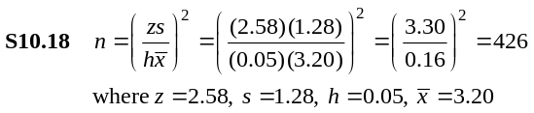
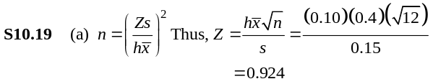Sample size 45 is not adequate. They need 381 more observations.
Referring to Appendix I (Standard Normal Table I.2), corresponding Area = 0.64 = 64%. The confidence level when n = 12 is 64%.

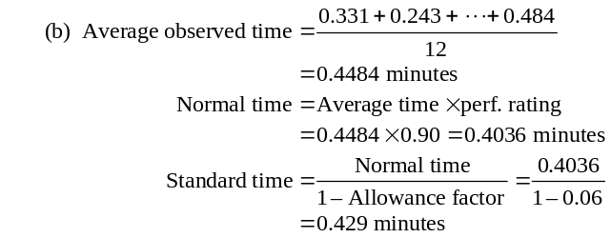S10.20
Element | Observed Time (minutes) |  |  |  |  | Perf.  Rating
Prepare daily reports | 35 | 40 | 33 | 42 | 39 | 120%
Photocopy results | 12 | 10 | 36a | 15 | 13 | 110%
Label and package  reports | 3 | 3 | 5 | 5 | 4 | 90%
Distribute reports | 15 | 18 | 21 | 17 | 45b | 85%
a Photocopying machine broken (included in delay factor).
b Power outage (included in delay factor).
Calculating average observed time:
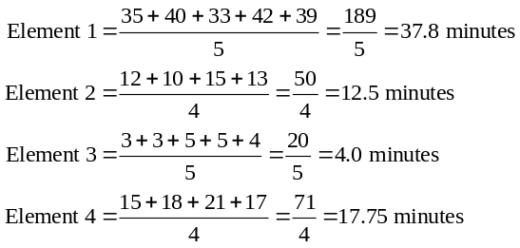
(a) Calculating normal time for each task element:
Normal time = Observed time × Performance rating
Element 1 = 37.80 × 1.20 = 45.36 minutes
Element 2 = 12.50 × 1.10 = 13.75 minutes
Element 3 = 4.00 × 0.90 = 3.6 minutes
Element 4 = 17.75 × 0.85 = 15.09 minutes
Normal time for the process:
Normal time for process = Sum of normal times for elements
= 45.36 + 13.75 + 3.6 + 15.09
= 77.8 minutes
(b) Standard time for the process:
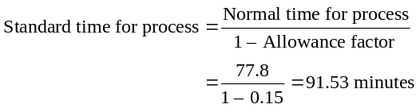
(c) Sample size:
From the equations relating to a normal distribution, we know
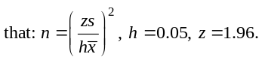
Job Element | Mean Cycle  Time | S² | S | Sample*
Prepare daily reports | 37.80 | 13.70 | 3.7 | 15
Photocopy results | 12.50 | 4.33 | 2.1 | 44
Label and package  reports | 4.00 | 1.00 | 1.0 | 96**
Distribute reports | 17.75 | 6.25 | 2.5 | 31
Sample size for the entire task must be at least 96 samples.
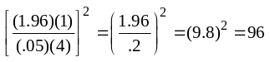*All fractional sample sizes are rounded to the next highest integer value.
**
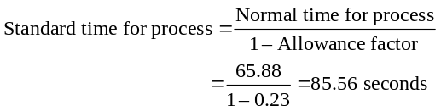S10.21 (a)
Job Element | Observed Time (seconds) |  |  |  |  | Perf.  Rating
Grasp and place  bag | 8 | 9 | 8 | 11 | 7 | 110%
Fill bag | 36 | 41 | 39 | 35 | 112a | 85%
Seal bag | 15 | 17 | 13 | 20 | 18 | 105%
Place bag on  conveyor | 8 | 6 | 9 | 30b | 35b | 90%
a Bag breaks open, include as part of delay in allowance factor.
b Conveyor jams, include as part of delay in allowance factor.
Note: If bags break open with any regularity, then these
observations would be included in the time for this element . . . it would be part of the element and task.
Calculating average observed time:
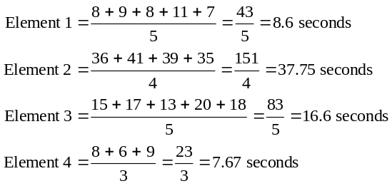
Calculating normal time for each task element:
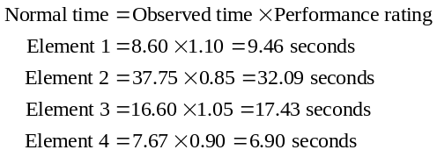
Normal time for the process:
Normal time for process = Sum of normal times for elements
= 9.46 + 32.09 + 17.43 + 6.90
= 65.88 seconds
Standard time for process:

(b)
Calculating Sample Size
Job Element | Mean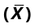 | Desired  Accuracy  (h) | Std. Dev.  Required  (Z) | Std. Dev. of  Sample  (S) | Samples  Required
Grasp and place bag | 8.60 | 0.05 | 2.58 | 1.52 | 83
Fill bag | 37.75 | 0.05 | 2.58 | 2.75 | 14
Seal bag | 16.60 | 0.05 | 2.58 | 2.70 | 70
Place bag on conveyor | 7.67 | 0.05 | 2.58 | 1.54 | 107

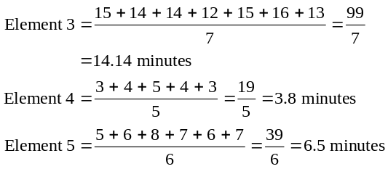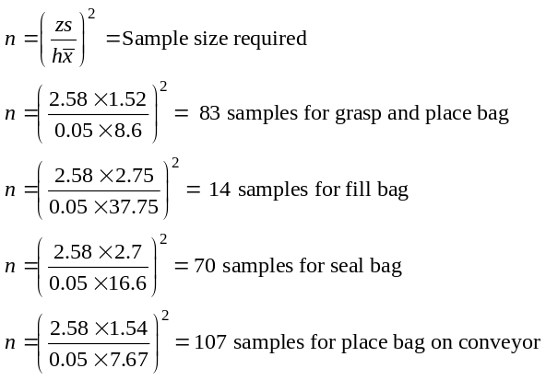
Therefore, if all cycles must be studied together (the typical
case), 107 cycles must be studied.
S10.22 (a)
Job Element | Observed Time (minutes) |  |  |  |  |  |  | Performance  Rating
Select correct  muffler | 4 | 5 | 4 | 6 | 4 | 15* | 4 | 110%
Remove old  muffler | 6 | 8 | 7 | 6 | 7 | 6 | 7 | 90%
Weld/install  new muffler | 15 | 14 | 14 | 12 | 15 | 16 | 13 | 105%
Check/inspect  work | 3 | 4 | 24* | 5 | 4 | 3 | 18* | 100%
Complete  paperwork | 5 | 6 | 8 | — | 7 | 6 | 7 | 130%
*Employee stopped to talk to boss—exclude (personal time).
Calculating average observed time:
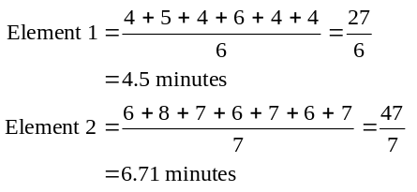

Calculating normal time for each task element:
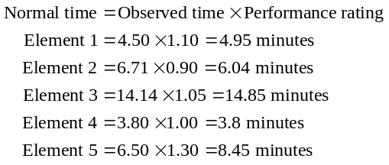
Normal time for the process:
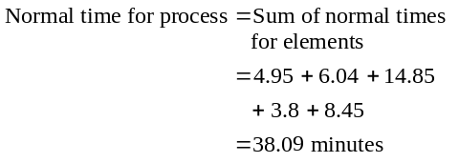
Standard time for process:
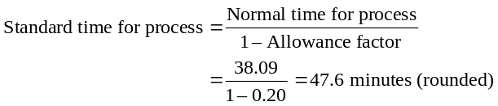
(b) Calculating sample size:
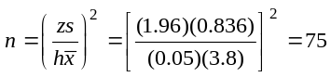
Job Element | Mean  Observed  Time | Desired  Accuracy  (h) | Std. Dev.  Required  (Z) | Std. Dev.  of Sample  (S) | Samples  Required
Select correct muffler | 4.50 | 0.05 | 1.96 | 0.836 | 53
Remove old muffler | 6.71 | 0.05 | 1.96 | 0.755 | 20
Weld/install new muffler | 14.14 | 0.05 | 1.96 | 1.345 | 14
Check/inspect work | 3.80 | 0.05 | 1.96 | 0.836 | 75
Complete paperwork | 6.50 | 0.05 | 1.96 | 1.048 | 40
Element 4 required a sample of 75, thus the sample size for the study is 75.
S10.23 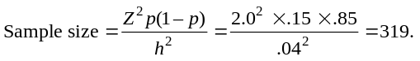
Therefore, minimum sample size is 319 samples.
S10.24 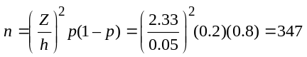(rounded up)
S10.25
(a) Standard time in minutes per chair = 480 minutes per day/130 chairs
= 3.69 minutes
(b) Total allowances = 18% (6 + 6 + 6 = 18)
Normal time = Standard time × (1 – Allowance time)
Therefore:
3.69 × (1 – .18) = 3.69 × .82 = 3.026 minutes = Normal time
S10.26 858 + 220 + 85 = 1,163
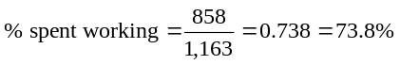
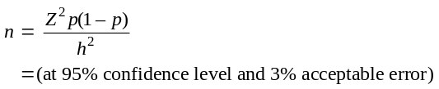S10.27 (a) 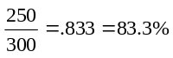
(b)

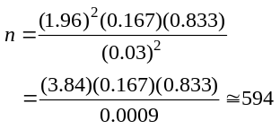
(c) The sample size was only about half the desired size.

S10.28 |  | Motion | TMU’s
 | 1 | Reach 4 inches for the pencil | 6
 | 2 | Grasp pencil | 2
 | 3 | Move pencil 6 inches | 10
 | 4 | Position the pencil | 20
 | 5 | Insert the pencil into the sharpener | 4
 | 6 | Sharpen the pencil | 120
 | 7 | Disengage the pencil | 10
 | 8 | Move the pencil 6 inches | 10
 |  |  | 182
Given that 1 TMU = 0.0006 minutes: Time = 182 × 0.0006 = 0.1092 minutes (6.55 seconds)
S10.29 Tell the supervisor that delay was over 8% and the sample
size was adequate (for a 95% confidence and 3% acceptable error):
Delay:
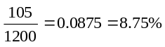
Sample size:
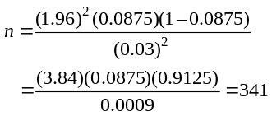
S10.30
- Minutes available per day = 6 hours – 2 hours
= 4 × 60 min = 240 min
- Minutes of room cleaning required
200 room @ 30 min each = 6,000 minutes
200 room @ 15 min each = 3,000 minutes
Total of 9,000 minutes = 150 hours
- Each employee can clean 8 rooms (4 hr/.5 hr = 8)
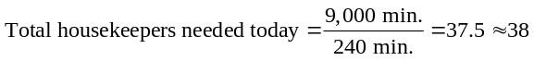 Each employee can refresh 16 rooms
(4 hr/.25 hr = 16)

- 400 room @ .5 hr each = 200 hr
200/4 = 50 employees required to thoroughly clean all 400 rooms.

Case Study
JACKSON MANUFACTURING CO.
1. Cycle times
x |  |  | 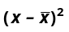
2.05 | 1.90 | 0.1488 | 0.0221
1.92 | 1.90 | 0.0188 | 0.0004
2.01 | 1.90 | 0.1088 | 0.0118
1.89 | 1.90 | –0.0112 | 0.0001
1.77 | 1.90 | –0.1312 | 0.0172
1.80 | 1.90 | –0.1012 | 0.0102
1.86 | 1.90 | –0.0412 | 0.0017
1.83 | 1.90 | –0.0712 | 0.0051
1.93 | 1.90 | 0.0288 | 0.0008
1.96 | 1.90 | 0.0588 | 0.0035
1.95 | 1.90 | 0.0488 | 0.0024
2.05 | 1.90 | 0.1488 | 0.0221
1.79 | 1.90 | –0.1112 | 0.0124
1.82 | 1.90 | –0.0812 | 0.0066
1.85 | 1.90 | –0.0512 | 0.0026
1.85 | 1.90 | –0.0512 | 0.0026
1.99 | 1.90 | 0.0888 | 0.0079
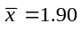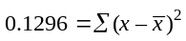
h = 0.05, n = 17, z = 3
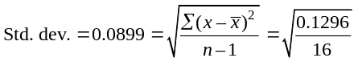

This can be rounded up to 9 for statistical accuracy.
2. A sample size of 17 is more than adequate, given the low variation in cycle times; indeed, a sample size of 8 or 9 would be adequate.
3. Available time = 7.5 × 60 = 450 minutes
Cycle time = 1.90; normal time = 1.90 × 1.15 = 2.185
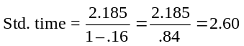minutes
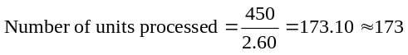
4. $100 = ($1250 × 8.0) = Total cost per day
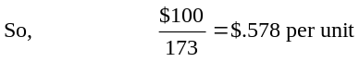
Internet Case Study*
CHICAGO SOUTHERN HOSPITAL
1. Sampling plan:
- Do studies on all shifts (probably four shifts; three each day plus the weekend shift) to get data on workload differences by shift. Then cross-check with other studies by function (intensive care, maturity, postoperation, etc.). If identifiable differences are present, then judgments will need to be made about additional studies.
- It may well be that major differences exist, suggesting that more extensive studies be made.
- Generate a random sample of which nurse to sample when using a true random device, such as the random number table provided in the text in Appendix III.
- Perform an adequate number of samples (per question 2).
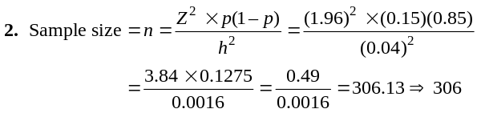
Note: The sample size will change if the 15% vs. 85% is not close to accurate. This difference may suggest that a larger sample be taken.
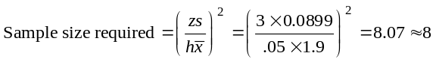3. By structuring the study across different nurses, different shifts, and different hospital processes (areas/functions), there should be an adequately diverse cross section. Some postsample check to ensure a mix of nurses, shifts, and functions should be made.

* This case study is found at our Companion Web site, www.prenhall.
com/heizer.

